Natural resources conservation service
conservation practice sPECIFICATION
649E – Structure for wildlife, Bat Houses

- SCOPE
The works consists of installing bat house structures with the materials and to the dimensions shown on the drawings. Installed bat houses will address wildlife habitat deficiencies where there is a lack of natural bat roosts and where artificial structures will enhance those habitats, and/or to attract and utilize insect-eating bats as a control method for pest insects in crops, vineyards, orchards, and other land uses, or when it is necessary to evict a bat roost from a building or structure and replace it with a structure designed for bats.

- AREAS AND TIMING
Installation sites of bat houses shall be shown on the plans, while the methods used, and timing of treatment are shown on the Implementation Requirements Sheet and supporting materials. More specific planning guidance and requirements on locations and timing of installing bat houses is listed below.

III. PLANNING AND GENERAL REQUIREMENTS
Selecting a Bat House
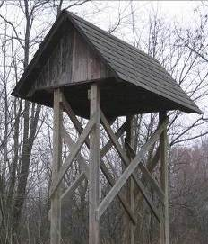
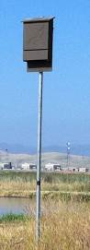
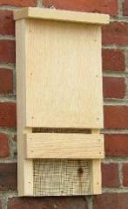
Bat houses are generally referred to by the size, number of roosting chambers contained and by the mounting method that will be used. Provided below are a few examples.

free-standing,
multi-chambered
pole mounted,
multi-chambered
wall mounted,
single chamber

Size. Selecting the size of a bat house can depend on several factors, including: the space available, the quantity of bats to be housed, the number of houses to be installed, economic feasibility and personal preference.
- There is a minimum size requirement, refer to the design criteria section.
If the goal is to size the bat house to a known (or desirable) number of bats, there is a quick calculation available to estimate how many bats can utilize a space:
cubic inches of roost space divided by 4 cubic inches = bat house capacity
Roosting Chambers. In short, more roosting chambers result in better bat use. Multi-chambered boxes are better at stabilizing internal temperatures and they provide increased space for bats (to help prevent overcrowding). A commonly built, economical box has four chambers. Appendix A
Mounting Methods
Research has shown that bat houses installed on buildings^{1]}, poles or dead trees are easiest for bats to locate and they have greater occupancy rates. Some mounting considerations are provided below:
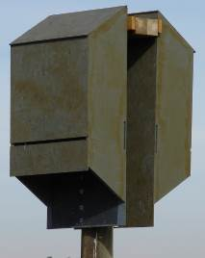
- Single-chambered bat houses (Appendix B) are not recommended to be mounted on poles since they are less thermally stable. For greatest success, install these houses on building.
- Mounting two multi-chambered bat houses back-to-back on poles (with one facing north and the other south) is ideal. Place houses approximately 3/4-inch apart and cover both with a roof or otherwise protect the center roosting space from rain.
Wood, brick or stone buildings with proper solar exposure are excellent choices. However, bat houses mounted to metal buildings are rarely used. Regardless of the type of bat house, all require the same design, construction and installation guidance provided in this document.
Criteria for Design and Constructions
Whether you build or buy a bat house, the following criterion has been proven to provide the greatest success in attracting and maintaining bat use and in ensuring bat safety. Appendix A & B
Box size must be at least 24 inches tall and 14 inches wide. Taller, wider boxes are better.
Roost chambers will extend the width of the interior of the box and be at least 20 inches tall.
The spacing between chambers (called crevices) should create a ¾ to 1 inch crevice. The best crevice size for most North American bats is ¾ inch. Larger species (such as pallid bat) should have a 1 inch crevice. Greater than one inch crevices are not recommended; they attract wasps and other non-target animals.
- Wider chambers may require spacer blocks between partitions to ensure crevice size.
- To prevent wasps from building nests at the top of the roosting chambers, extend the chambers to the roof or ceiling.
Landing areas are necessary for bats to access the roosting chambers. They can be created by extending the length of the backboard at least 3 inches below the entrance, or by having a 3 inch recessed roost chamber so bats can land on the lower inside walls. A 6 inch landing is best.
Ventilation. Where July high temperatures average ≥85°F (see figure 1), include a front ventilation slot. The vent being as long as the house is wide by ½ inch. In some designs, ventilation slots may be in a pattern or design.
- For boxes 24-36 inches tall, ventilation slots should be approximately six inches from the bottom of the house.
- For boxes taller than 36 inches, ventilation slots should be 10-12 from the bottom.
- Side vents are optional.
Roughened interior surfaces are required on the chambers and landing area to provide footholds for bats. There are generally three options:
1. Use rough-cut wood, or
2. Roughen surfaces by mechanically creating scratches or grooves horizontally at roughly ¼-½ inch intervals ($\frac{1}{16}$ inch deep), or
3. Cover surfaces with durable plastic mesh (⅛ or ¼ inch square mesh) securely stapled every two inches so it does not sag, buckle or curl. Mesh must not have sharp edges. Metal mesh, hardware cloth or aluminum window screen is not acceptable as these can injure bats.
Prevent leaks and drafts by ensuring tight construction with no unplanned gaps. Caulk or glue all joints.
Smooth all edges. Any screws, hardware or other sharp objects (including splinters) must not protrude into the box. Any exposed metal edges (e.g. roofs) must be smooth.
Protect the interior (optional) by applying two coats of dark, exterior grade, water-based stain (not paint). Paint fills grooves, making them unusable. Apply stain after creating scratches or grooves or prior to stapling plastic mesh.
Protect the roof (optional) by applying shingles, metal or other similar waterproof material. A compromised roof will make the box incapable of retaining the necessary thermal conditions.
Materials
- Pressure – or chemically-treated wood must NOT be used, as they contain substances that may be harmful to bats
- Plywood for exteriors must be exterior grad (e.g. ACX, BCX, T1-11) and should be at least ½ -inch thick with at least four plies. Cedar and pine are also recommended. While 1-2 inch thick exterior plywood is best for the sides. To lengthen longevity of bat house construct roofs with ¾ inch plywood
- All Major components should be assembled with exterior grade screw. Nails, brads, or staples do not hold well over time. To increase longevity, use screws rather than nails.
- If mounting on a pole:
  - Use a scheduled-40 galvanized steel pole with the inside diameter >2” or a 4”x6” treated wooden post
  - There are numerous alternative materials available such as plastic or fiber-cement board. Contact a NRCS biologist for guidance.

Maintaining Proper Roost Temperatures may be the single most important factor for a successful bat house. Interior bat house temperatures should be warm and as stable as possible; ideally staying between 80ºF to 100ºF in the summer. This provides for the greatest range of species use and is ideal for mother bats to raise their young.
Bat house temperatures are influenced directly by the exterior color, compass orientation, the amount of sun exposure, as well as the how well the house is constructed and mounted.
1. Exterior Color
Bat houses are far more successful at attracting bats if they are painted or stained. It helps provide the proper internal temperature for bats and increases the structure’s life span.
Why? The box will heat up a few degrees faster in the morning (which is critical in the spring), and it will average about five degrees warmer during midday.
- Use exterior-quality, water-based stain or latex paint, and use flat paint for best solar absorption. Do not use oil based products as they may be harmful to bats. Provide at least three coats of paint.
The appropriate shade of color depends upon geographic location and the amount of sun exposure (e.g. adjust to darker colors where there is less sun to help absorb the solar heat). The figure below is provided to assist in shade selection. The actual color is not as important provide the shade is correct
Figure 1. Average July daily high temperatures
① < 85° F. use black
② 85°-95° F. use dark/medium shade
③ 95°-100° F. use medium/light shade
④ > 100° F use white or light shade

1
2
3
4

2. Compass Orientation
East-, southeast-, or south-facing are generally best for single houses in most climates. A 140° azimuth (SE) is reported to be optimal.
3. Sun Exposure
At least six hours of direct daily sun is recommended for bat houses. Full, all-day sun is often successful in all but the hottest climates. If only partial day sun is available- morning sun is preferable.
You may have to experiment to get the right placement and temperature range. You can also use a thermometer attached next to, or inside, the box to check if temperature high’s/ low’s.

Bat House Placement
Greatest success will be achieved in areas of diverse habitat, especially where there is a mixture of varied agricultural use, natural vegetation, wooded areas, and water. This will produce different types of insects at different times throughout the night and over a season to accommodate a resident population of bats.
There appear to be some differences in preferences between houses used by colonies as compared to individuals. Colonies appear to prefer house attached to buildings with most roosting in houses attached to barns and bridges. Colonies nest most often at locations with shade or morning sun and located within one quarter mile of available water. Individuals most often use houses attached to poles away from buildings, with full sun or afternoon sun.

Tree Cover. When possible, bat houses should be located along the edges of forest, riparian or other tree cover. Maintaining a distance of 25-50 feet is ideal; however, avoid placing the bat house closer than 20 feet to tree cover (to reduce shading and aerial predation). Take into consideration expected tree growth over the next 10 years.
Water. Most bats choose roosts within 1/4 mile of slow moving water which is available through the summer (preferably a stream, lake or wetland). Bat houses near these water edges are ideal.
- When natural water sources are not available, or they are not available through the summer, consider developing water sources designed for bats to safely use. Refer to the publication “Water for Wildlife Handbook”.
Height. The bottom of the bat house must be at least 12 feet above ground; 15 - 20 feet is ideal.
- Structure mounted
  - Mount house at least 12 feet off the ground or attached to a building or bridge
  - Houses mounted under eaves are often successful.
  - Place house(s) as close to roof line as possible
- Pole Mounted
  - Mounting two bat houses back-to-back on poles (with one facing north and the other south) is ideal. Place houses 3/4-inch apart and cover both with a galvanized metal roof to protect the center roosting space from rain.
  - On a 4x6-inch wooden post; telephone pole or metal pole with an inside diameter greater than two inches
0.25 mile from water
Figure 2. Desirable bat house location.
20-50 feet from trees
N
front of the box oriented east-, southeast or south
bat house
0.25 mile from water
Figure 2. Desirable bat house location.
20-50 feet from trees
N
front of the box oriented east-, southeast or south
bat house
0.25 mile from water
Figure 2. Desirable bat house location.
20-50 feet from trees
N
front of the box oriented east-, southeast or south
bat house
0.25 mile from water
Figure 2. Desirable bat house location.
20-50 feet from trees
N
front of the box oriented east-, southeast or south
bat house

Bat House Placement (Cont.)
Locations to Avoid:
Flight Obstructions and Predator Perches. Ensure that the bat house is placed at least 20 feet from the nearest tree branches, wires or potential perches for aerial predators. Ten feet below the box should also be free of shrubby vegetation, debris or other flight obstacles.
Shade. Avoid shaded, cool locations. Bat houses installed on live trees are often not successful, largely due to shading.
Night Light. Bat houses should not be lit by bright lights, avoid placing boxes near yard or security lights. Do not mount on light poles.
Bright Shiny Surfaces. Do not mount bat houses over bright or shiny surfaces that can reflect light directly into the box.
Pesticides. Bats may not be able to live in areas of heavy pesticide use due to the lack of available insect food sources.
Air Quality and Wind. Bat houses should not be located near burn barrels or air vents with smoke, fumes or exhaust. Avoid windy areas such as exposed hilltops.
Disturbances. Avoid locations where the bat house may be vibrated, bumped or otherwise disturbed. e.g. a post-mounted house in a pasture where livestock will rub on the post.
Metal Building. Bat houses built on metal buildings are rarely used.
Roads. Avoid locations directly along busy roads where they are vulnerable to traffic.
Guano. Most bat houses have open bottoms, which keeps guano from accumulating inside. Guano will, however, end up on the ground underneath, so avoid placing bat houses directly above windows, doors, walkways, etc.
- 2-4 inch spacers between a bat house and the wall may reduce guano deposits on the wall.
- A potted plant or a shallow tray may be placed underneath, but do not use a deep container (unless 1⁄4-inch or smaller mesh covers the entire top of the container), as baby bats that fall from the bat house could become trapped inside.
Timing of Installation
Bat houses can be installed at any time of the year, but they are more likely to be used during their first summer after installation, if installed before the bats return in spring.
When evicting bats from a building or structure
When using bat houses in conjunction with excluding bats from a building or structure, install adequately sized bat house(s) at least two to six weeks before the actual eviction.
The bats should be evicted at a time in the early spring or fall when flightless young are not present. Use a one-way valve design that will permit bats to exit, but not return.

Occupancy
Be patient. Ninety percent of bat houses will occupied within two years, with 50 percent occupancy in the first year (IBC 2011). If a bat house remains unoccupied after two full years, consider repositioning of modifying the house.
Bats have to find new roosts on their own. They investigate new roosting opportunities while foraging at night, and are expert at detecting crevices, cracks, nooks and crannies. Existing evidence strongly suggests that lures or attractants will not attract bats to a bat house.
Bats will generally not overwinter, except in extreme southern locations. But they are loyal to their warm-season roosts and will return to a bat house year after year as long as it continues to meet their needs.
IV. monitoring
Periodic monitoring of this practice is essential to determine if wildlife habitat goals are met and if modifications are needed.
- Bat boxes should be checked at least twice a month in the summer with a flashlight in daylight hours to count adult bats and young.
- Boxes should be checked at least once during the fall and once during the winter with a flashlight in daylight hours to check for migrating and overwintering bats.
- Bats are sensitive to excessive human disturbance. For large colonies, count the bats as they emerge from the box at dusk.
- To determine if a box contains a nursery colony (late May through June), check the box 45 minutes after sundown after the adults have left to feed. The young are pink and flightless and cling to the insides of the box.

V. Operation and Maintenance
To achieve your wildlife objective of attracting bats, bat houses needs periodic operation and maintenance to maintain satisfactory performance. Repaint outside of the box after the colony has left in the fall and replace caulk as needed. The minimum lifespan is 5 years.
Periodic monitoring of this practice is essential to determine if wildlife habitat goals are met and if modifications are needed.
- Wasp and mud dauber nests should be cleaned out each winter after bats and wasps have departed. These wasps are beneficial, and bats will coexist with them, but they can pose problems if they become too numerous. Dried nests are easily broken up with a yardstick or similar long, thin object. If more regular cleaning is necessary, conduct it at night when the bats are out foraging.
- When cleaning guano, dampening the droppings then disinfected the areas with a solution of 1 part bleach to 20 parts water. Seal dropping in a plastic bag for disposal.

It is highly recommended to move nest boxes to a new location, if after 2 years of monitoring it appears that the nest boxes are not being occupied at any time of the year.

Safety
A HEPA filtered face mask and gloves should be worn when handling bat houses or bat guano, or when disturbing the soil below a bat house. Clothes worn while should be washed immediately.

.

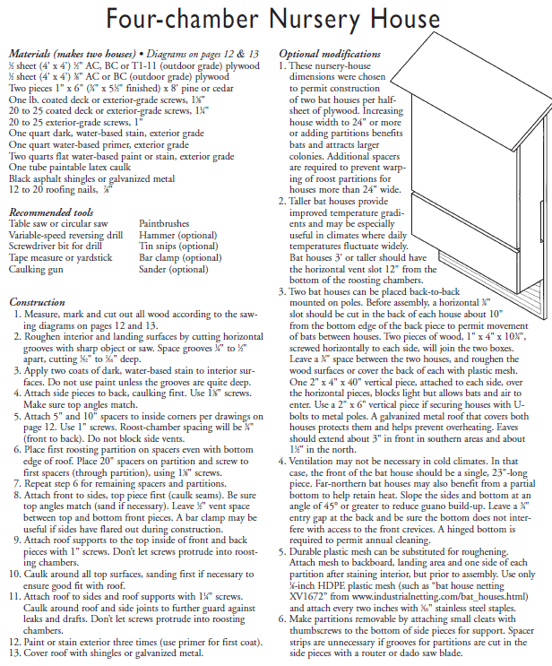
APPENDIX A
Bottom of Form

Top of Form

Drawings by Bat Conservation International The Bat House Builders Handbook, 2013

Drawings by Bat Conservation International, The Bat House Builders Handbook, 2013

Appendix B
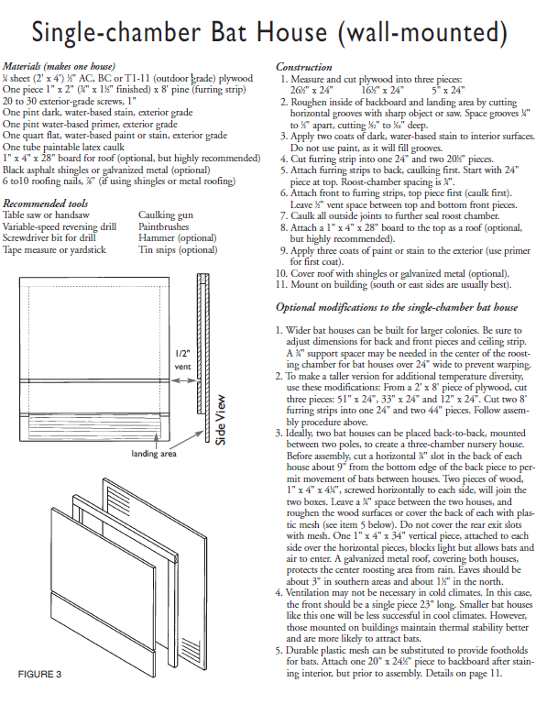
Drawings by Bat Conservation International, The Bat House Builders Handbook, 2013

